# CS 255 System Design Document Template

Marshall Bowser

6/17/2023

## UML Diagrams

### UML Use Case Diagram

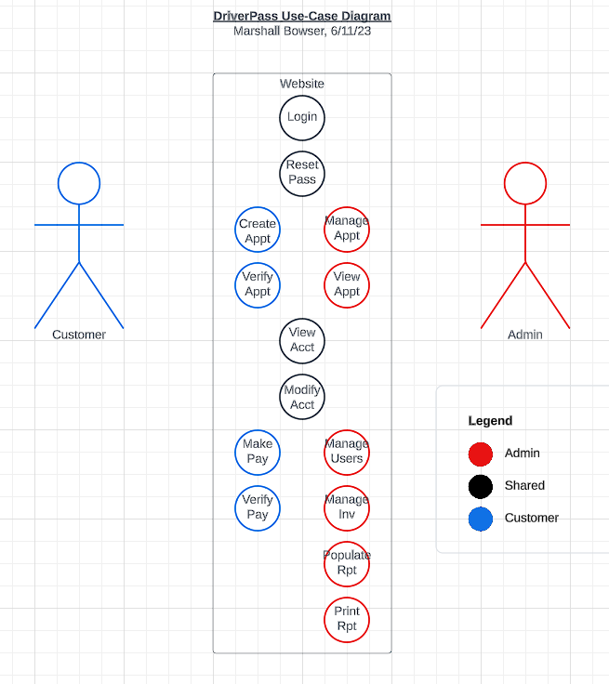

### UML Activity Diagrams

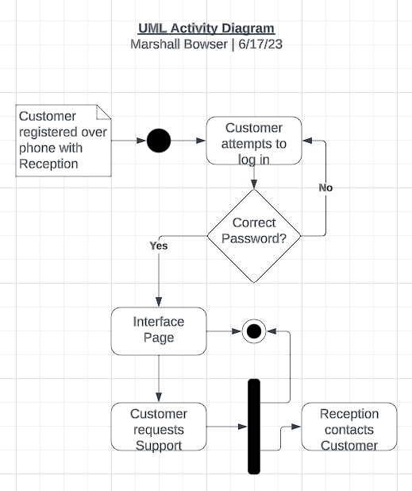

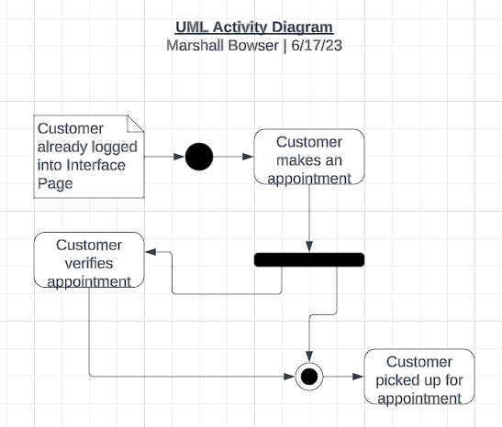

### UML Sequence Diagram

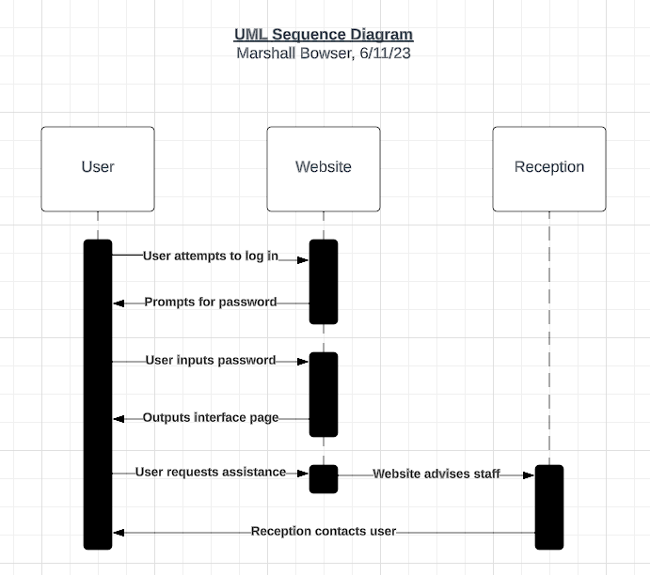

### UML Class Diagram

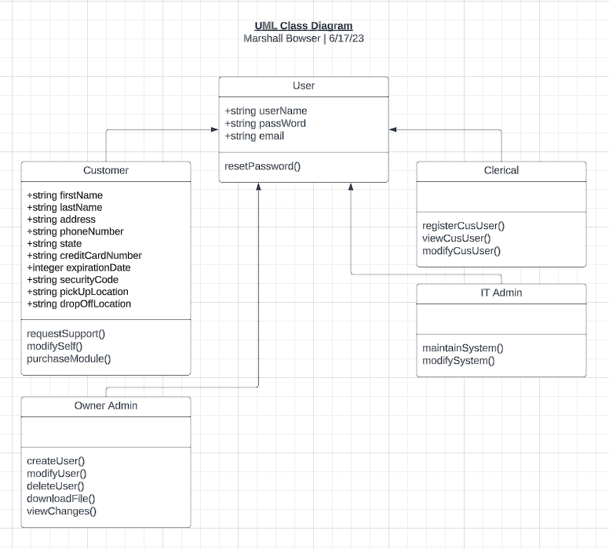

## Technical Requirements

The system requirements are such that the least costly development method is the creation of a website that functions as both a customer and employee portal. The website will be capable of displaying the required information across multiple platforms (Windows, iOS, Android, etc.). The website approach eliminates many of the technical requirements employee and customers would need to use a formal computer program. While the option will exist to populate reports for offline review, this unfortunately necessitates that all users will need to be connected to the internet in order to interact with and change the information on the website. The client has expressed a desire to outsource server purchase/maintenance responsibilities to a web hosting service (which usually includes that the web host manages the physical server hardware, but not always). The client will also need to purchase a domain name and work with the relevant vendor to ensure that there are no business disruptions (automatic payments, domain protection service, etc.). We will dedicate a staff member to working with DriverPass in order to ensure that the services they are purchasing and agreeing to both meet their needs and do not exceed reasonable market rates. In the event that physical server hardware is required for the web hosting service, DriverPass will assist with designing a physical server with appropriate hardware such as a 10g network connection, multiple terabyte solid state disk hard drives in RAID 1 configuration, and more.